Mendota News
City of Mendota
P. O. Box 50688
Mendota, MN 55150
Phone: 612-803-0517
Email: cityofmendota@gmail.com
Kathy Krotter, City Clerk
Council Members:
Brian Mielke, Mayor: 612-270-9091
Joan Perron: 651-452-9359
Steve Golias: 651-452-1837 Melody Rasmussen: 651-454-6442
Clark Donnelly: 651-785-5790
Building Permits:
MNSpect, Building Official:
952-442-7520
Mailing Address: 235 First St W
Waconia, MN 55387
Police:
Kelly McCarthy, Chief of Police: Non-emergency: 651-452-1366
Emergency: 911
Fire:
Emergency: 911

City Attorney:
Tom Loonan, City Attorney:
715-808-8842

The City of Mendota holds City Council Meetings at 7:30 on the second Tuesday of every month upstairs at the
VFW Post 6690
1323 Sibley Memorial Hwy.
Mendota, MN 55150

Winter 2023

SPECIAL ELECTION MN HOUSE DISTRICT 52B!
Governor Walz has ordered a special election to fill the vacancy in District 52B on Tuesday, December 5, 2023. A special primary will be held on Thursday November 16, 2023. House District 52B encompasses 14 precincts in Mendota, Eagan and Mendota Heights.
Candidates are:
Chris Whitfield DFL
Jay Miller DFL
Bianca Virnig DFL
Cynthia Callais DFL
Cynthia Lonnquest Republican
Charles Kuchlenz Libertarian

Neighborhood watch!
This year there has been an increase in vehicles that have been stolen. Always lock your vehicles and remember to NEVER leave your keys inside the car. If you see something out of the ordinary, please call 911. Better to be safe than sorry.

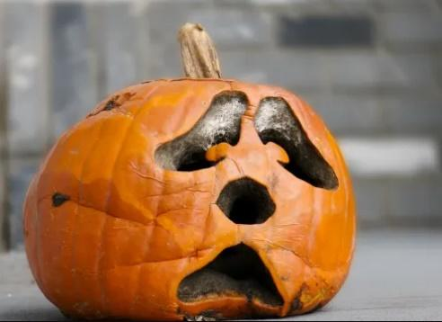
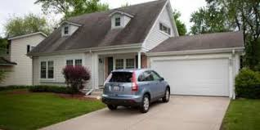

When pumpkins turn scary
Rotten pumpkins can be composted in your backyard or picked up with your yard waste. You can also drop off pumpkins at a yard waste site for as little as $1 per 30-gallon yard waste bag. Most cities will collect pumpkins the first weekend of November at a drop-off site for free – see event listing below. Remove candles, wax and any non-pumpkin material. No painted or glittered pumpkins can be composted — these must go in the trash. FREE Pumpkin collection will be at the Mendota Heights City Hall on November 4, 2023 all day long.
Annual Tree Lighting!
The annual tree lighting ceremony is on again this year. It will be the Saturday after Thanksgiving, November 25, 2023. More information to come from the Mayor and his wife, Nancy. Hope to see you all there. Thanks
Holiday light collection.
The city clerk will have a box at the post office by the bulletin board to collect holiday lights and extension cords. Any old or unused holiday lights and extension cords should never go into the trash or recycling. Please place your cords and lights in the box at the post office for the clerk to take to the recycling center. Thank you so much for your help with this. Kathy
Declutter cleaners for a fresh start
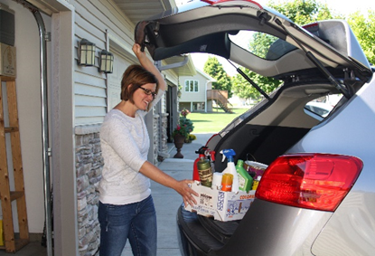Sprucing up your home should include properly cleaning out unwanted chemical cleaning supplies. Don’t wait to declutter your surplus of cleaning sprays and unused drain cleaners. Gather all your cleaning products and potentially hazardous items from under-the-sink, storage closets and garage. Keep what you would use in the next year and put everything else in a box to bring to The Recycling Zone.
The Recycling Zone is your one-stop drop-off for most products labeled caution, warning, danger or poison. Residents can bring cleaners, personal care products like nail polish and sunscreen, paint, yard and garden chemicals, bug killers and more for free.
The site is open four days a week all year. Find open hours, directions and the full list of items accepted at www.dakotacounty.us, search recycling zone.
Partially funded by the Minnesota Pollution Control Agency and Dakota County.

I would like to thank everyone who came to the Mendota Picnic in September. It was so great to see everyone.
HAVE A SAFE AND WONDERFUL HOLIDAY SEASON. 