Mendota News



**City of Mendota**

P. O. Box 50688

Mendota, MN 55150

Phone: 651-322-0827

Email: [cityofmendota@gmail.com](mailto:cityofmendota@gmail.com)

Kathy Krotter, City Clerk

**Council Members:**

Brian Mielke, Mayor: 651-261-2751

Joan Perron: 651-452-9359

Steve Golias: 651-452-1837

Melody Rasmussen: 651-454-6442

Kathleen Krotter: 651-454-3913

**Building Permits:**

Mike Andrejka, Building Official:

612-597-9667

Mailing Address: 1011 Sibley Memorial Highway, Lilydale, MN 55118

**Police:**

Kelly McCarthy, Chief of Police:

Non-emergency: 651-452-1366

Emergency: 911

**Fire:**

Emergency: 911

**City Attorney:**

Tom Lehmann, Criminal Attorney:

651-439-2878

**The City of Mendota holds City Council Meetings at 7:30 on the second Tuesday of every month at the**

**VFW Post 6690**

**1323 Sibley Memorial Hwy.**

**Mendota, MN 55150**

Winter 2017

Annual Tree Lighting!

December 1st, Mayor Mielke and his wife, Nancy held their 7th annual Christmas tree lighting ceremony at the park. Special thanks to Dan and Arlene Dahlberg and Joe and Gloria Schaefer for always helping get the tree ready for the big day. Thanks to everyone who participated and hung out to enjoy hot chocolate and cookies. And who didn’t like visiting with Santa and singing Christmas Carols and talking with friends and neighbors. Thanks again Brian and Nancy!!!

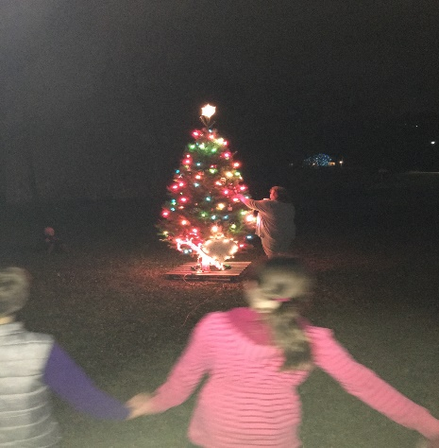

Snow plowing

Now that winter is here, the City of Mendota asks the residents to be aware of city ordinances relating to parking and snow shoveling.

**In order to keep city snow removal costs down, please adhere to the following practices:**

* Please do not park in such a manner as to obstruct or interfere with the snow plowing or snow removal.
* **Also**, it is unlawful for any person to deposit snow/ice in the roadway.
* All snow and ice should be removed from public sidewalks 12 hours after the snow has ceased to fall. Thank you for your cooperation in this manner.

**Your snow plowing service will appreciate your efforts.**

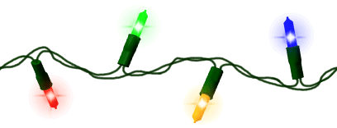

Recycle**Holiday Lights & Extension Cords**

Holiday lights (or any type of string lights) and electrical cords will be accepted at the following locations until January 31st, 2018.

**Mendota Post Office City of Mendota Heights Year-round drop-off**

A box located in the entry way City Hall The recycling Zone

1310 Sibley Memorial Hwy. 1101 Victoria Curve 3365 Dodd Road

Mendota, MN Mendota Heights, MN Eagan, MN

651-905-4520

**Did you know?** LED lights use up to 99 percent less energy than standard holiday lights.

**Christmas Trees & Wreaths**

For artificial trees and wreaths still in good condition, there are many reuse and donation opportunities. Real Christmas trees and wreaths with wires removed are banned from household garbage. Most garbage haulers offer pick-up service 1–3 weeks after Christmas. Some garbage haulers require residents to schedule a pick-up time. Call your garbage hauler for details.

Residents can also drop off real Christmas trees and wreaths at a local compost site.

RecycleTrees and wreaths for composting or garbage pick-up must have all of the following removed:

* Ornaments
* Lights
* Tinsel
* Stands
* Plastic bags
* Metal/wire

Artificial wreaths and trees that cannot be reused and real wreaths with wire may be placed in the garbage.

**Recycle your Fluorescent Light Bulbs**

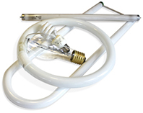Fluorescent bulbs contain mercury which can harm health and the environment if not disposed of properly.  Do not place in the garbage or in your home recycling cart.

All fluorescent light bulbs (compact fluorescent light bulbs, linear tubes, U-shaped, circular) are accepted at: **All Batteries + Bulbs locations**

[**The Recycling Zone**](http://www.co.dakota.mn.us/Environment/RecyclingZone/Pages/default.aspx)  **Home Depot Lowes**   
3365 Dodd Road 1300 E Mendota Road‎ 1795 Robert St.

Eagan, MN Inver Grove Hts., MN West St. Paul, MN   
651-905-4520 651-552-9020 763-367-4139

**Did you know?** If every American home replaced just one light with a fluorescent bulb that's earned the [ENERGY STAR](http://www.energystar.gov/), we would save enough energy to light 3 million homes for a year.