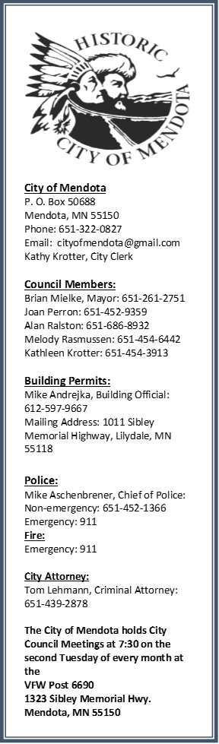
Mendota News
Summer 2016

Mendota Days:
This is a friendly reminder that Mendota Days is July 9, 2016. The parade starts at noon and after the parade there will be a variety of things to do. The VFW will have hot dogs, brats, hamburgers, and beverages to buy. They will also be having two bands for your listening entertainment. There will be several vendors, selling their merchandise for you to look at and of course buy. There will be a carnival behind the VFW for the kids, and everything will be free for them. There will be a jumpy house for even more entertainment. Lucky’s will be having Bingo after the parade and of course food and drinks. The Sibley House will be having a kid’s art day and other activities that they can do. Axels will have appetizers at half price all day during Mendota Days. This year so many people have helped to put on Mendota Days and the Mendota Days Committee would like to thank them all: Bard Flowers, Benson Metals, Getten Credit Company, VFW, Oxendale Markets, Neighbors Inc., Lucky’s and many more. If I have missed someone I am sorry. PLEASE come and join us for a day of fun, meet your neighbors, meet new friends, and of course have a great time.
Reserving the Gazebo:
The park is available for all Residents of Mendota to use. There is a sign-up sheet at the Gazebo hanging on the wall for you to sign and put the date that you would like to use it. The only day not available is the Saturday after Labor Day. That is reserved for our annual Mendota Picnic where we all get together as a community and enjoy the day. The city supplies hot dogs and beverages, and everyone brings a dish to share. We even get the Mayor to cook the hot dogs. There are games and prizes for the kids and they give away a new bike, one for the girls and one for the boys. There is even a horse shoe tournament for the men and woman. So sign up and play. The only thing the city asks is that you respect the park and clean up after you are done. Please do not vandalize the park or Gazebo. It is there for everyone to use.

Meet the new City Clerk:
Hello, my name is Kathy Krotter. Most of you know who I am but some of you have no idea, so let me fill you in to where I am from. I grew up in Mendota on the corner of Second and E Street with my parents Howard and Audrey Adelmann. I have a sister Julie and a brother Ken. My mother was originally from Mendota, whose father was the first Sheriff of the town of Mendota. The jail displays pictures of him in his work atmosphere. Once I graduated from High School, I moved to Eagan and lived there until 2005, when I moved back to Mendota into my Aunt Lois’s home. Along with me, is my husband Richard, children Robert, Jennifer, Joe, Sara and my favorite granddaughter Bryanna. I love being back in Mendota and getting to know all of you.

Recycling and picking up after your pets:
This year as a community project, the park commissioner has taken on recycling as a concern with the environment. At the park there are two garbage containers and one is for recycling. As all of you know we can recycle, plastic, cardboard, pop cans, water bottles and so much more. Please make an effort to recycle and help make the Earth cleaner and healthier. Also many of the residents of Mendota play in the park, either playing kick ball, basketball or in the playground swinging and sliding. Please if you let your dog in the park to play with you, clean up after them. I hate coming home with dog do-do on my shoes after being in the park. Enjoy the outdoors and get some fresh air.

Recycling of prescription drugs:
Mendota Heights Police Department has a Medication Disposal Box in the lobby of the Police Department where Dakota County residents can safely and anonymously dispose of their prescription drugs and over‐the‐counter medication.

Have a safe and Happy Fourth of July!!!!!!!

