Mendota News



**City of Mendota**

**P O Box 50688**

**Mendota, MN 55150**

**Phone: 651-322-0827**

**Email:**

[cityofmendota@gmail.com](mailto:cityofmendota@gmail.com)

**KimberLee West, City Clerk**

**Council Members:**

**Brian Mielke, Mayor**

**Joan Perron**

**Alan Ralston**

**Erick Lehet**

**Melody Rasmussen**

**Building Official:**

**David Neameyer**

**For Inspections and Permits call: 651-600-2176**

**Chief of Police:**

**Mike Aschenbrener**

**City Attorney:**

**Tom Lehmann**

**651-439-2878**

**The City of Mendota holds City Council Meetings at 7:30 on the second Tuesday of the month at the VFW Post 6690**

**1323 Sibley Memorial Hwy.**

**Mendota, MN 55150**

**January 2014**

**NO NEED TO MAIL YOUR SEWER PAYMENTS!**

There is a sewer payment / suggestion drop box located in the entry way of the post office building.

Highway 13 Project Starting in 2015

The Minnesota Department of Transportation (MnDOT) and the City of Lilydale are teaming up to reconstruct Highway 13. The project will begin at I-35E and extend into the City of Mendota. An overlay, curbs and gutters and a new storm sewer system will be some of the improvements.

**Your Health & the Environment**

[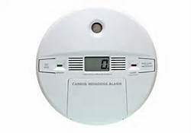](http://www.bing.com/images/search?q=carbon+dioxide+detector+images&id=5556FD44084801A395B02567270680FD312A1FF8&FORM=IQFRBA#view=detail&id=5556FD44084801A395B02567270680FD312A1FF8&selectedIndex=0)Page Content

​Here are some easy ways that you can avoid common environmental health hazards:

**Install a carbon monoxide detector**   
Carbon monoxide is highly toxic to humans and animals. Installing a carbon monoxide detector protects you and your family from accidental exposure. In addition, don't use a generator, charcoal grill, camp stove, or other gasoline- or charcoal-burning device inside your home, basement, or garage or near a window, door, or vent. Don't run a car or truck inside a garage attached to your house, even if you leave the door open. Don't heat your house with a gas oven.   
**Test your home for radon**   
[Test your home for radon](http://www.co.dakota.mn.us/HealthFamily/HealthyLiving/Environment/Pages/test-your-home-for-radon.aspx) by using a low-cost detection kit. If your home has high levels of radon, take steps to reduce radon levels by sealing cracks and increasing ventilation.

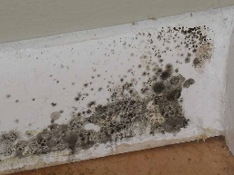**Avoid mold**

If your home has been contaminated with sewage or flood waters, remove and discard items that cannot be washed and disinfected, such as mattresses, carpets, rugs, drywall, insulation, and paper products. Thoroughly clean all hard surfaces with hot water and detergent.

**Prevent lead poisoning**  
Lead can be hazardous to health, especially in children. Lead is found in many unexpected places, including inside and outside homes in.

**Properly ventilate your home** Use chemicals outside or open a window when using them.

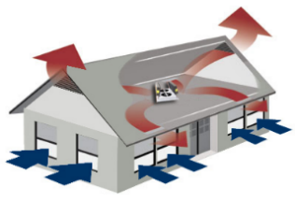

For more information contact Dakota County Public Health at:

651-554-6100

**Common Household Hazardous Waste Items**

Cooking Safety Tips:

1. Pay attention and stay in the kitchen while you are frying, grilling or broiling.

2. Turn off the stove if you have to leave the kitchen, even for a short time.

3. Have a kid-free zone of at least three feet around the stove and area where hot food or drinks are prepared.

4. Keep anything that can catch fire – oven mitts, wooden utensils, food packaging – away from the stove.

5. Keep a lid nearby when cooking to smother small grease fires. Smother the fire by sliding the lid over the pan and turning off the stove. Leave the pan covered until completely cooled.

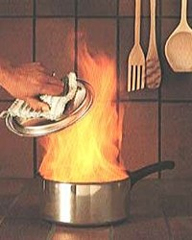

Products that require special handling are found in many areas around your home. In the garage, you’ll find automotive and recreation materials, including aerosol cleaners, degreasers, antifreeze, oil and gas. Yard and garden care items include fertilizers, pesticides, weed killer, bug spray, and charcoal lighter fluid.  
Household items may include aerosol cans with product remaining, drain cleaner, mothballs, nail polish/remover, oven cleaner, spot removers, compact fluorescent bulbs, and mercury-containing thermometers and thermostats. 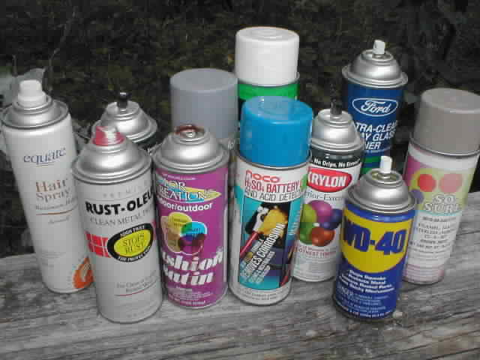  
Some batteries contain hazardous metals. Check out our [battery recycling options](http://www.rethinkrecycling.com/residents/materials-name/batteries#overview).  
Ask your recycling service provider if empty latex paint cans and aerosol cans are accepted curbside. If not, dispose of empty aerosol cans and dried latex paint cans (lids off) in the garbage.   
If containers aren’t empty, your choices include using them up, giving them away or taking them to a household hazardous waste drop-off site. Some household hazardous waste drop-off sites also offer a free product reuse area, so your unwanted items can be used by someone else.  
Hazardous waste drop-off sites, including hours and materials accepted, are listed [here](http://www.rethinkrecycling.com/residents/household-hazardous-waste-drop-sites#tab2_content). You’ll also find more information on [managing your waste](http://www.rethinkrecycling.com/residents/household-hazardous-waste-drop-sites#overview) in ways that protect you, your family and the environment.

For household hazardous waste and recycling drop-off:

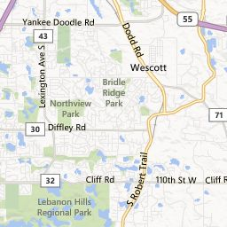

**\*New Recycling Zone Hours for all Residential Items**

**Wednesday: 9 a.m.–8 p.m.   
 Thursday: noon–8 p.m.   
 Friday: 9 a.m.–5 p.m.  
 3365 Dodd Rd, Eagan, MN 55121**

**(651) 905-4520**

**Recycle Your Holiday Lights and Extension Cords**

**Now through January 31,2014, holiday lights will be accepted at**

**The Recycling Zone. Old or non-working holiday lights and**

**extension cords can be dropped-off at:**

**The Recycling Zone Hours**

**3365 Dodd Road Wednesday - 9am – 8pm**

**Eagan, MN 55121 Thursday - 12pm – 8pm**

**Friday - 9am – 5pm**

**Saturday - 8am – 5pm**

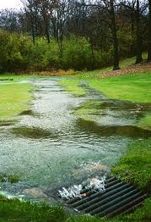**What is Stormwater Runoff?**

Stormwater runoff is rainwater that runs off of lawns, rooftops, houses, buildings, driveways, parking lots, paved and unpaved roads, compacted dirt, sidewalks and other impervious surfaces which prevent the water from naturally soaking into the ground.

**Why is Stormwater Runoff a problem?**

Urbanization increases the need for effective storm water management because land development alters the natural vegetation and flow of surface water, resulting in an increase in the volume and velocity of storm water runoff. This can cause flooding, stream bank erosion and impervious surfaces pollutants. Stormwater pollution can have detrimental effects to our water resources.

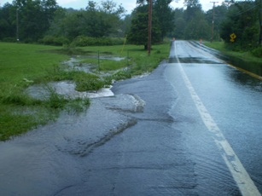**What can you do to Reduce Stormwater Runoff Pollution?**

1. Educate your friends and family about stormwater topics and downstream pollution.

2. Put litter in its place, not on the ground!

3. Recycle your car batteries, used motor oil and vehicle fluid properly.

4. Compost your yard waste.

5. Use fertilizers and pesticides sparingly.

6. Sweep extra fertilizer, grass clippings and dirt on your driveway or road back onto your lawn.

7. Reduce, reuse and recycle the amount of cleaning and maintenance chemicals used.

8. Never dump or pour any motor oil, chemicals, pet waste, trash, dirty or soapy water, leaves, grass, fertilizers, pesticides or anything else down a storm drain or in a drainage ditch!

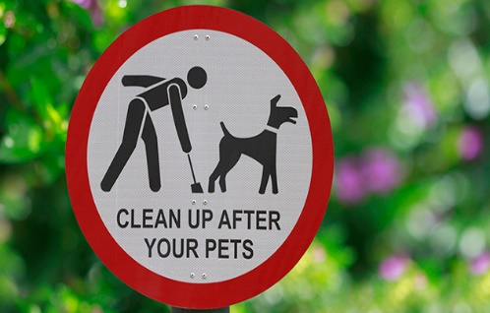**When your Pet goes on the Ground**

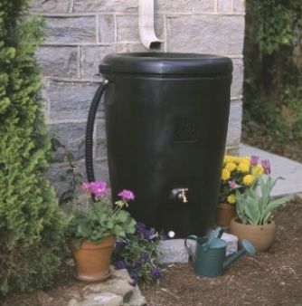If pet waste is left on sidewalks, streets, yards or other open areas, it can be washed away by rainwater into nearby storm drains. Pet waste can be a source of harmful bacteria. Some storm drains flow directly into lakes, streams and rivers delivering bacteria and other pollutants to the water. Whether in one’s own yard or walking a dog in a public area, it’s easy to do the right thing by collecting pet waste with a “pooper-scooper” or a plastic bag. When finished, just place the waste and bag in the garbage.

**Recycle your Rainwater by:**

**1. Use a Rain Barrel**

A rain barrel is attached to a downspout, which collects and stores rainwater from rooftops that can be used to water lawns or gardens.

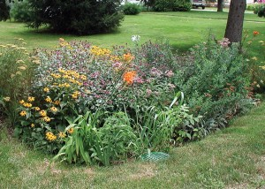**2. Plant a Rain Garden**

A rain garden is a man-made planted depression located in a natural low point that is designed to absorb rainwater runoff from impervious urban areas. This will reduce stormwater runoff by slowing it down, acting as a filter and allowing the stormwater to soak into the ground instead of draining directly into storm sewer systems and streams.

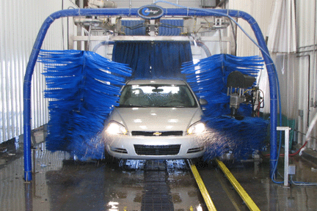

**3. Wash your Car at a Car Wash that Treats and Recycles its Water**

Most commercial car washes use 60% less water in the entire washing process than a simple home wash uses just to rinse off a car. Most soaps contain ingredients that can harm fish and water quality. The soap, combined with the dirt and oil washed from a car, flows from the driveway to nearby storm drains and eventually into streams. If it is necessary to wash a vehicle at home, wash the car on the lawn. This will allow the pollutants to soak into and be filtered by the ground before releasing into downstream water bodies.

**Get Involved and Be a Part of the Solution to Stormwater Pollution**

**Concerned About Global Warming? Recycle Your Paper!**

Global warming, it’s a big topic these days, and people want to know what they can do to help. Most people don’t realize it, but one way to reduce global warming is to recycle paper products. Paper recycling helps in the following ways:

* **Energy Savings** - Pulp and paper is the 5th largest industrial energy consumer in the world! Production of recycled paper uses 65 percent less energy than paper production using raw materials. Reducing energy consumption reduces greenhouse gas emissions.
* **Tree Preservation**- Recycling one ton of paper saves 17 trees from being cut down. Each tree helps reduce global warming by capturing and holding carbon dioxide, a major greenhouse gas.
* **Water Savings** – Methane and nitrous oxide, both greenhouse gases, are emitted during wastewater treatment. Production of recycled paper uses 80 percent less water than paper production using raw materials, reducing methane and nitrous oxide, and therefore greenhouse gas emissions!

When you think of all of the things that you can do to help reduce global warming, remind yourself that recycling your paper products is an important step. And don’t forget your cans and bottles – recycling all types of containers saves energy and natural resources, helping to reduce global warming. Rethink Recycling. You can recycle more kinds of paper than you think. To learn more, contact your community recycling program or visit:  [www.RethinkRecycling.com](http://www.rethinkrecycling.com/), the metro area’s resource for recycling and waste disposal.

-Please keep roads free of vehicles so that snow plowing can be done in an efficient manner-

Thank you the City of Mendota

Candles may be pretty to look at but they are a cause of home fires — and home fire deaths.

Remember, a candle is an open flame, which means that it can easily ignite anything that can burn. Think about using flameless candles in your home. They look and smell like real candles.

Never leave a child alone in a room with a burning candle. Keep matches and lighters up high and out of children’s reach, in a locked cabinet.

“CANDLE WITH CARE”

Blow out all candles when you leave the room or go to bed. Avoid the use of candles in the bedroom and other areas where people may fall asleep.

Keep candles at least 12 inches away from anything that can burn.

If you do burn candles, make sure that you...

Use candle holders that are sturdy, and won’t tip over easily.

Put candle holders on a sturdy, uncluttered surface.

Light candles carefully. Keep your hair and any loose clothing away from the flame.

Don’t burn a candle all the way down — put it out before it gets too close to the holder or container.

Never use a candle if oxygen is used in the home.

Have flashlights and battery-powered lighting ready to use during a power outage. Never use candles.



MHPD has a **Medication Disposal Box** in the lobby of the PD where Dakota County residents can safely and anonymously dispose of their prescription drugs and over‐the‐counter medication.