Dakota County Minutes of the Regular Meeting
held Tuesday December 9, 2014
Pursuant to due call and notice thereof, the regular meeting of the City Council, City of Mendota, Minnesota
held at 7:30 pm at the Mendota VFW 1323 Sibley Memorial Hwy Mendota, Minnesota

Present – Mayor Brian Mielke, Council Members; Alan Ralston, Joan Perron, Erick Lehet and Melody Rasmussen, Building Official; Mike Andrejka, City Attorney; Tom Lehmann, Chief of Police; Mike Aschenbrener and City Clerk; KimberLee West.

1. Mayor Mielke opened the City Council Meeting at 7:30 p.m. with the Pledge of Allegiance.

Minutes - Motion by Councilmember Perron, seconded by Councilmember Lehet to approve the
November 11, 2014 City Council Minutes. Passed 5-0.

Agenda – Motion by Councilmember Ralston, seconded by Councilmember Perron, to approve the agenda as presented. Passed 5-0.

2. Treasurer’s Report - Transfer $1441.67 from Sewer Fund to General Fund for wastewater bill. Transfer $10,000.00 from MM Fund to General Fund to maintain the General Fund balance. Motion by Councilmember Ralston, seconded by Councilmember Perron, to approve the above transfers. Passed 5-0.

3. 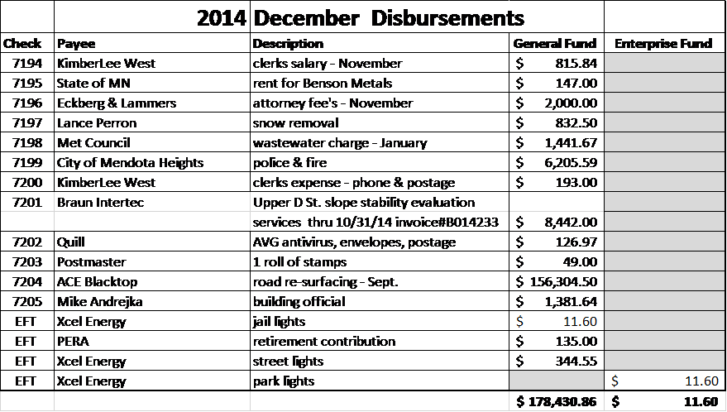
Add check # 7205 in the amount of $1,381.64 payable to Building Official Mike Andrejka and check # 7200 in the amount of $193.00 for clerks’ expenses. Motion by Councilmember Lehet, seconded by Councilmember Ralston to pay the bills. Passes 5-0.

4. Final Levy Certification – a discussion was held on the 2015 tax levy. It was decided to certify the levy at $ 164,591.93 for 2015.

5. Apostolic Church - asked the council to forgive a $3000 fire alarm fee from the year 2013. The Council lowered the fee to $2000.

6. Home Federal E-Bank Statements - The city will not receive paper statements in the mail for the five accounts. They will now come via e-mail.

7. Storage of city records at Lilydale City Hall- Mayor Mielke said Lilydale will allow the City of Mendota to store old records at their City Hall. There is no fee. Motion by Councilmember Ralston, seconded by Councilmember Lehet to agree to store Mendota City records at Lilydale City Hall. Passed 5-0.

8. Public Comment - opened at 7:48 p.m.
Resident Mark Proctor asked the council if there was a plan to when work will begin on the hillside above his home. Mayor Mielke read an e-mail for Engineer Brian Miller. Mayor Mielke said that a computer model is being created of the area that will give several scenarios of optional repairs. At the January meeting more information will be available. Mayor Mielke suggested that Lance not plow snow to block the gates on upper D Street because the gates will need to be opened when construction begins in early spring.
Public Comment closed at 7:52 p.m.

9. Council Comment - opened at 7:52 p.m.
Councilmember Rasmussen said she attended a NDC4 meeting about Comcast. Councilmember Rasmussen said the Century Link would like to meet with the City to discuss a proposal.

Councilmember Lehet reported that the metal slide from Veterans Park is being stored at Benson Metals. In the spring Benson Metals will repair the slide. Councilmember Lehet said he has contacted the University of Minnesota to find a grad student to help with natural resources in the city. Councilmember Lehet thanked Mayor Mielke for the tree lighting at Veterans Park.

Councilmember Ralston said that Kathleen Kotter’s name is on the newsletter as a contact but she doesn’t begin her term until January. Councilmember Ralston said there have been vehicles parking and blocking driveways on Hwy. 13.

Mayor Mielke has mail for review. Mayor Mielke said that all the street lights on upper 2nd Street need to be checked by Xcel. Mayor Mielke thanked Councilmember Lehet for his 1 1/2 years of service to the city.

Councilmember Perron asked what ever became of the pools on Windy Ridge. Attorney Lehmann said he never heard back from the residents on Windy Ridge, Mayor Mielke will ask Brian Miller if the pools are included in the reports from Intertech. Councilmember Perron asked if a citation will be issued to the contractor that crossed barricades with a bobcat. Councilmember Perron asked who is keeping an eye on the condition of Upper D Street. Mayor Mielke said he will be more observant to the situation.
Council Comment closed at 8:11 p.m.

10. Staff Comment - opened at 8:11 p.m.
Building Official Mike Andrejka said there were 2 permits opened and 1 closed. Andrejka said he is still working on old permits that are still open. Andrejka told the council that after 1 phone call and 1 letter is sent to the resident about a final inspection then he will close the permit.

Chief of Police Mike Aschenbrener said there is a crime tracking application on the Mendota Heights Website that allows residents to see where crime is happening in the city.

Attorney Tom Lehmann - no comment

Clerk West said that she has updated the website on recycling information that is required by Dakota County. Clerk West also met with Dakota County and has turned in the 2015 Recycling Report due by February 1st. First quarter sewer bills and newsletters are ready to be mailed out on December 15th. Clerk West said she has updated the contact list and the monthly city to-do list to make things easier on the new city clerk.

11. Council to interview candidates for new City Clerk - Councilmember Melody Rasmussen is only observing the interview.
Mayor Mielke told the council that Clerk West posted the position. Some candidates were over qualified, others when asked for an interview decided to withdraw their application. Candidate Billie Jo Rassat met with Mayor Mielke and Mary Schultz Clerk of Lilydale for an interview.
Billie Jo Rassat said she has been a journalist for many years and has experience working with public officials. Rassat told the council that she has a good technical background and has written grants in the past. Rassat said she is currently working part-time and the clerk position would fit nicely into her schedule. A discussion was held on how to fill the open clerk position.
It was decided that the position should be filed immediately.
Motion by Councilmember Lehet, seconded by Councilmember Ralston to hire Billie Jo Rassat as the City of Mendota Clerk. Passed 4-0. Councilmember Melody Rasmussen abstains.

There being no further business, it was motioned by Councilmember Rasmussen, seconded by Councilmember Lehet to adjourn the City Council Meeting at 8:46 p.m.

Respectively submitted:

__________________________________________________
KimberLee West, City Clerk

